Week 12

1.OBJECTIVE

A binary number is a combination of 1s and 0s. Its n th least significant digit is the n th digit starting from the right starting with 1. Given a decimal number, convert it to binary and determine the value of the the 4 th least significant digit.

CODE

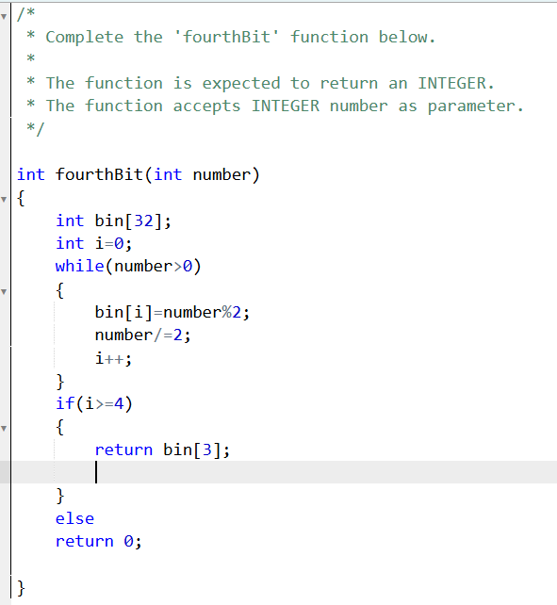

OUTPUT

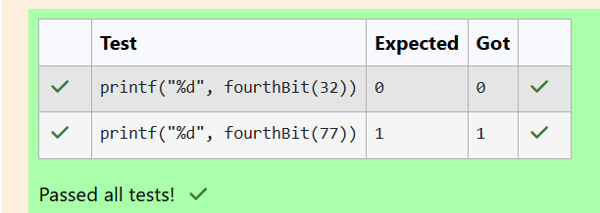

2.OBJECTIVE

Determine the factors of a number (i.e., all positive integer values that evenly divide into a number) and then return the p th element of the list, sorted ascending. If there is no p th element, return 0.

CODE

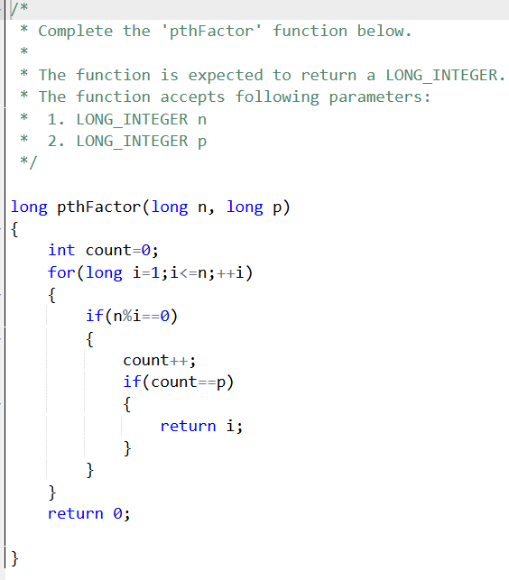

OUPUT

